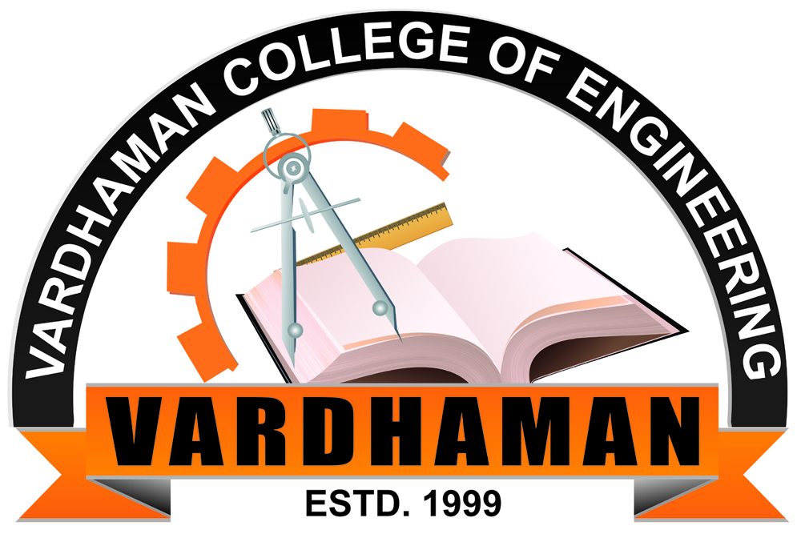
VARDHAMAN COLLEGE OF ENGINEERING
(AUTONOMOUS)
Affiliated to JNTUH, Approved by AICTE, Accredited by NAAC with A++ Grade, ISO 9001:2015 Certified
Kacharam, Shamshabad, Hyderabad – 501218, Telangana, India
DEPARTMENT OF FRESHMAN ENGINEERING

TITLE OF THE PROJECT: STUDENT D-FORUM BATCH NO: 11
Objectives of the Project | Flow of Execution | Project Setup (Screenshot of Final Project Prototype)
- The main objective of this project is to explore student’s education through interactive discussions.  - Sometimes it becomes difficult for the students to explore ideas as there are some people who can’t interact with people easily.  - Within the college they can’t find sufficient time to talk about it and also with the teachers. | STAGES OF IMPLEMENTATION:  Idea generation  Survey conducted on the problem statement  Define the problem statement  Find a solution  Research on website design  Implemented the frontend part | 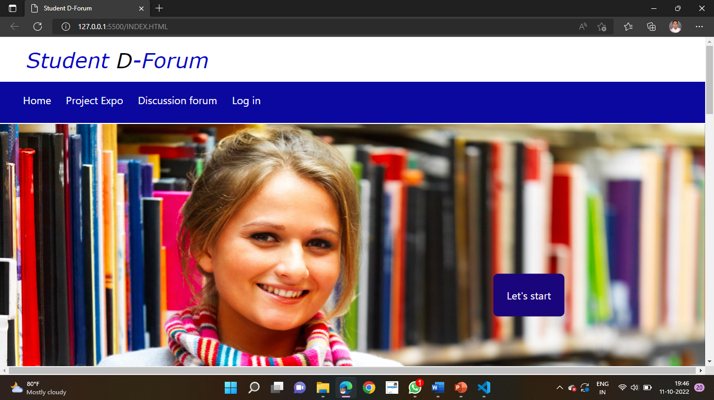
Block diagram |  | Hardware Components and Software tools
WEBSITE  FRONTEND DEVELOPMENT  DATABASE AND  BACKEND DEVELOPMENT  Roll number & Names of the Students:  1. 21881A05J0 SAMA SHIVA SAHITHYA REDDY  2 21881A05J2 SHAIK ABDULLAH  3. 21881A05J3 SHAIK ASIFFA  4. 21881A05J4 SINGARAM PRANAY  5. 21881A05K3 VELAKURTHI NAVYA |  | - Visual studio code editor  - Languages used HTML, CSS  - Laptop i3 processor  - W3 schools
Outcomes
- Students can participate from almost any location around the world, and the use of asynchronous instructional techniques can increase temporal flexibility.
- Students evolve themselves to explore the world.
.
Name of the Course Instructor(s):
Mrs. R. Srikanth/Mrs. Koti Tejaswi

